PRACTICAL 3

* **AIM:** Development of DFD and E-R diagram for the software domain problem.
* **What is DFD?**

A Data Flow Diagram (DFD) is a traditional **visual representation of the information flows within a system**. A neat and clear DFD can depict the right amount of the system requirement graphically. It can be manual, automated, or a combination of both.

It shows **how data enters and leaves the system**, what changes the information, and where data is stored.

The objective of a DFD is to show the **scope and boundaries of a system as a whole**.

It may be used as a **communication tool between a system analyst and any person** who plays a part in the order that acts as a starting point for redesigning a system. The DFD is also called as a data flow graph or bubble chart.

* **It provides an overview of**

What data is system processes

What transformation are performed.

What data are stored.

What results are produced, etc.

* **Following Observations About Data Flow Diagram:**

1. The name of the entity should be easy and understandable and **unique**.
2. Remember that DFD is not a flow chart. Arrows is a flow chart that represents the order of events; arrows in DFD represents flowing data.
3. A DFD does not involve any order of events.
4. The DFD should maintain consistency across all the DFD levels.
5. A single DFD can have a maximum of nine processes and a minimum of three processes.

* **Components of DFD:**

* **Levels in Data Flow Diagram (DFD)**

DFDs can be divided into different levels, which provide varying degrees of detail about the system. The following are the four levels of DFDs:

1. **Level 0 DFD**
2. **Level 1 DFD**
3. **Level 2 DFD**

**Level 0 Data Flow Diagram (DFD)**

* Level 0 is the highest-level Data Flow Diagram (DFD), which provides an overview of the entire system. It shows the major processes, data flows, and data stores in the system, without providing any details about the internal workings of these processes.

**1-Level Data Flow Diagram (DFD)**

* 1-Level provides a more detailed view of the system by breaking down the major processes identified in the level 0 Data Flow Diagram (DFD) into sub-processes. Each sub-process is depicted as a separate process on the level 1 Data Flow Diagram (DFD). The data flows and data stores associated with each sub-process.

**2-Level Data Flow Diagram (DFD)**

* 2-Level provides an even more detailed view of the system by breaking down the sub-processes identified in the level 1 Data Flow Diagram (DFD) into further sub-processes. Each sub-process is depicted as a separate process on the level 2 DFD. The data flows and data stores associated with each sub-process.

**DFD Diagram for online Job Portal**

* **Level - 0**

Request

Employers

Job Portal

Job Seeker

Response

Admin

* **Level – 1**

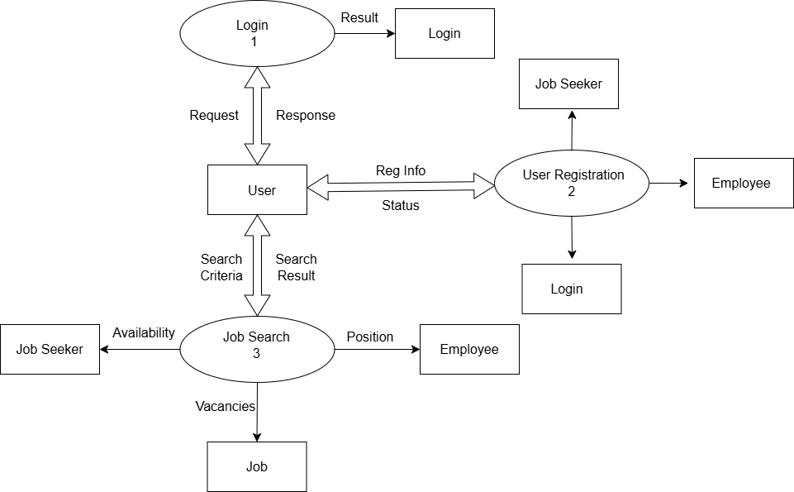

* **Level – 2**

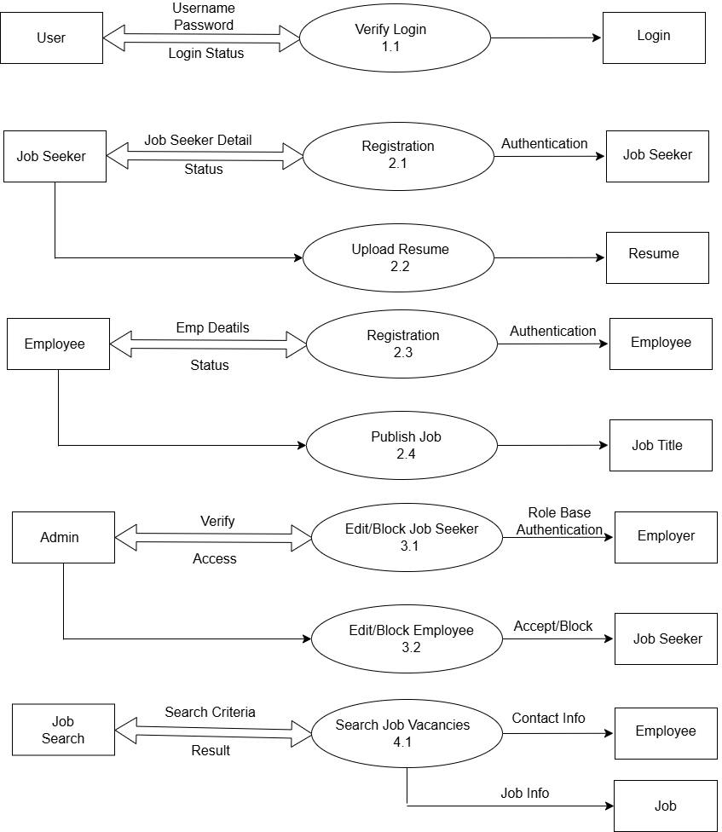

# What is an ER diagram?

# The Entity Relationship Model is a model for identifying entities (like students, car or companies) to be represented in the database and representation of how those entities are related. The ER data model specifies an enterprise schema that represents the overall logical structure of a database graphically.

An Entity Relationship (ER) Diagram is a type of flowchart that illustrates how “entities” such as people, objects or concepts relate to each other within a system. ER Diagrams are often **used to design or debug relational databases in the fields of software engineering,** business information systems, education, and research.

* **Why Use ER Diagrams In DBMS?**
* ER diagrams represent the E-R model in a database, making them easy to convert into relations (tables).
* ER diagrams provide the purpose of real-world modelling of objects which makes them intently useful.
* ER diagrams require no technical knowledge of the underlying DBMS used.
* It gives a standard solution for visualizing the data logically.
* **Symbols Used in ER Model**

ER Model is used to model the logical view of the system from a data perspective which consists of these symbols:

* **Rectangles:**

Rectangles represent Entities in the ER Model.

* **Ellipses:**

  Ellipses represent Attributes in the ER Model.

* **Diamond:**

  Diamonds represent Relationships among Entities.

* **Lines:**

Lines represent attributes to entities and entities sets with other relationship types.

* **Double Ellipse:**

 Double Ellipses represent Multi-Valued Attributes.

* **Double Rectangle:**

Double Rectangle represents a Weak Entity.

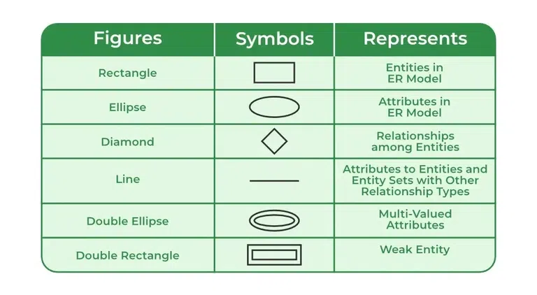

* **Components of ER Diagram**

ER Model consists of Entities, Attributes, and Relationships among Entities in a Database System.

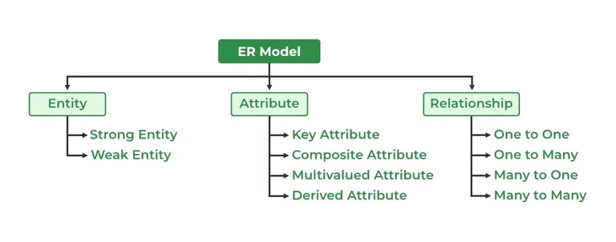

**Entity Relation Diagram for online Job Portal**

